User Documentation
ECET 230-002
Joshua Arriola & Maynor Roldan-Marin
Description of the product: This 281mm x 95mm circuit board is designed as a computer keyboard. The product is a 61-key switch keyboard that allows you to type words, letters, and symbols via a wired USB-C connection. This is also known as a 60 percent keyboard layout, meaning it contains only numbers and letters and uses 61 key switches. What's different about this product compared to a normal keyboard is that it allows the user to fully customize it to their preferences, both appearance-wise and function-wise. This circuit is equipped with an Atmega32U4, a microcontroller that scans a wire grid composed of rows and columns.
This circuit board is also equipped with a usb c port for power and 61 hot-swappable key sockets. The key sockets are crucial because they allow the key switches to be removed and replaced with different models if the user has damaged them or wants to change them. (shown in the picture below).
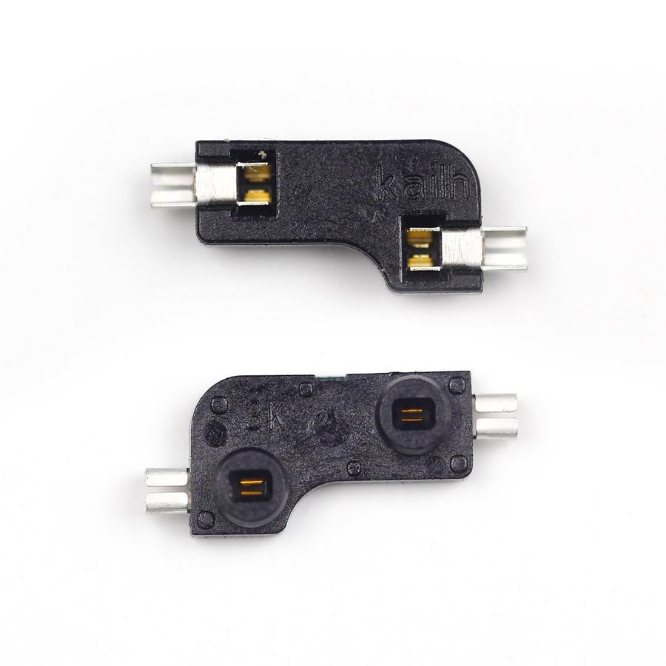
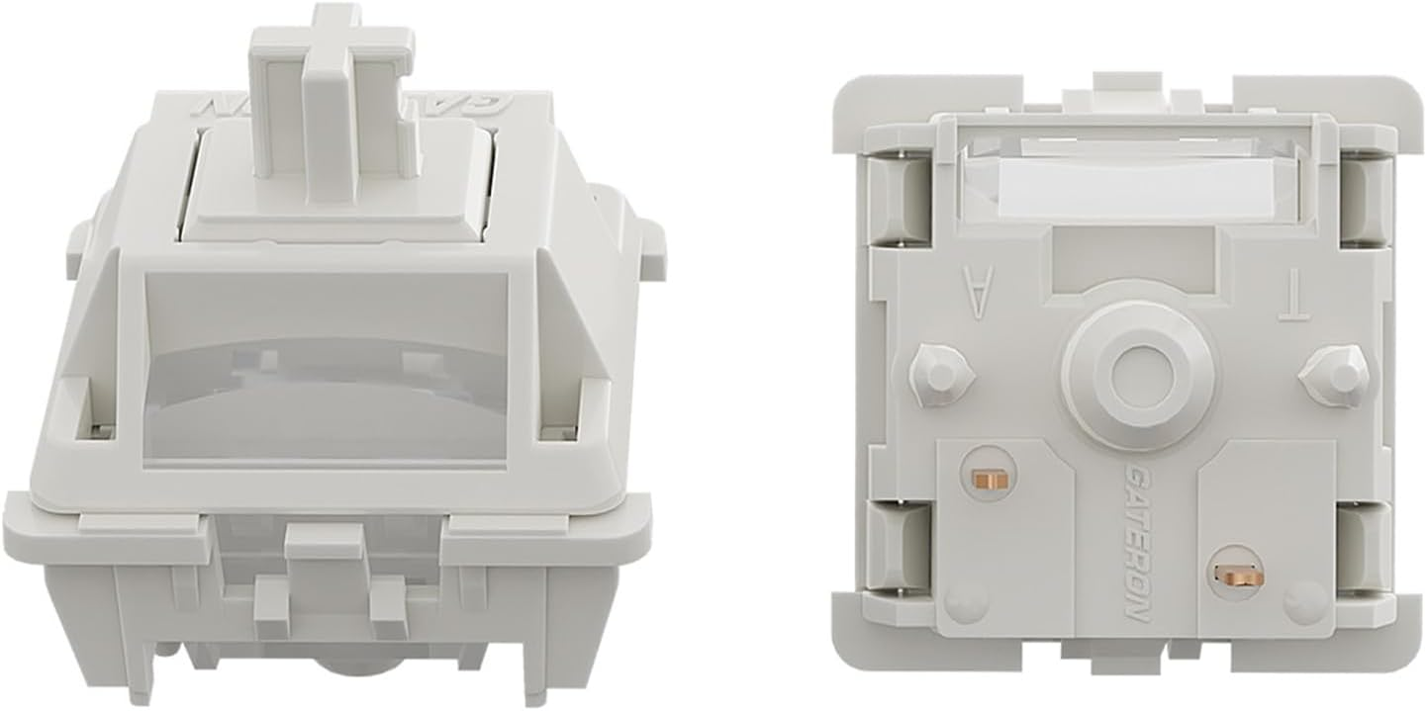

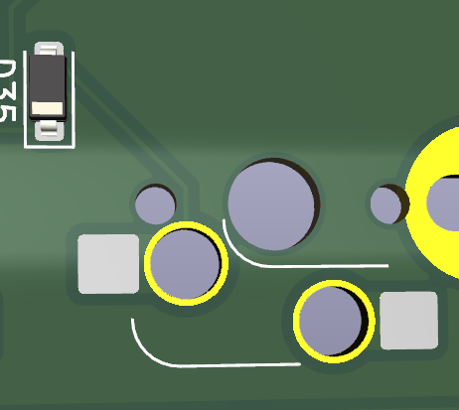
These allow the circuit board to be typed on by sending small jolts of electricity to the traces on the circuit, which the microcontroller senses. Once the microcontroller detects a signal from a specific position where the key switch is pressed, it will display a letter, number, or symbol. The way the switches are inserted (the picture on the left) is to grab the switch, line it up with the brass legs and the holes in the socket (the picture on the right), and slide the pins into the holes where you see the copper folds. Once slid in, these should stay in place and function as you type. One thing to note, though, is that some PCB manufacturing companies will actually solder the sockets onto the circuit board for you. If you would like to install them yourself, the next paragraph will give a brief explanation.

The picture above shows a 3D model of where the socket would go. If you look at the previous picture on the right, you will notice that the socket has two holes and two steel legs. To insert these, simply have the holes on the socket face down and the steel legs touching the square silver pad shown in the photo, which should turn out like this. The socket holes should align with the outline, and the legs should contact the square pads. Next, grab a soldering iron and some soldering wire, and add a bit of solder to the pads so it melts into the legs, soldering them directly to the board. If you flip the board, it should look like this (the second photo at the bottom).

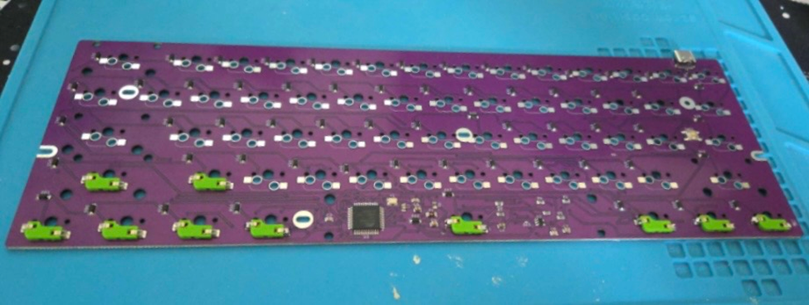

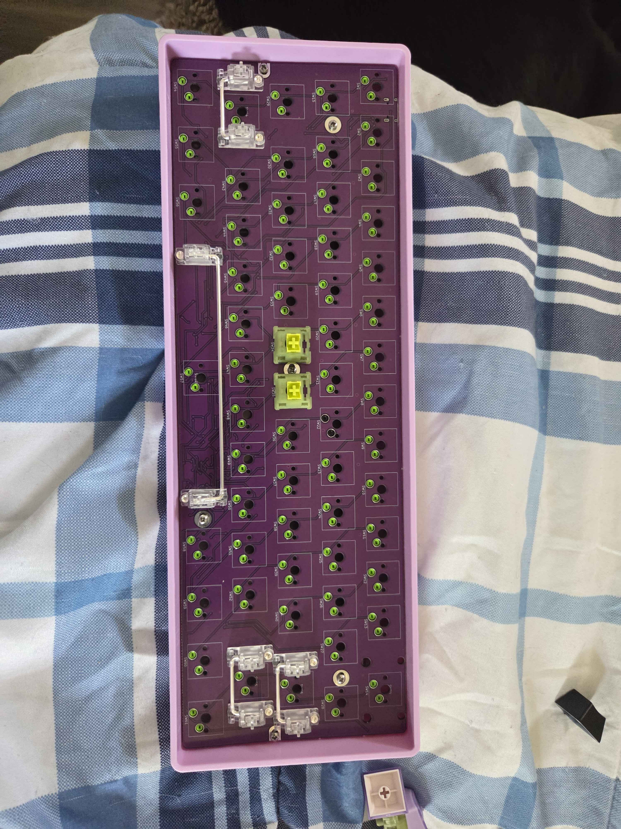

For this circuit board, you are going to want a shell or casing to hold the circuit board in place, and you will need exactly 61 mechanical key switches (either 3-pin or 5 models are fine, it will accommodate for either or). Key caps are also a must if you do not want to press the key switches directly. Key caps and key switches are largely a matter of user preference. A good starter for key switches would be generic Cherry MX Browns if you are on a budget.
Does it work right out of the box? The answer is no, you will need to install the coding firmware on this. If you flip the back of the board all the way to the left, you will see a hexagonal button that serves as a reset button, resetting the circuit board to allow firmware to be installed. The way you do that is by using QMK Toolbox (available on GitHub or Google; the link is below). Once you have downloaded the software to the computer, you will need the code, which will be in our GitHub repository (another link will be provided). After you have those two, grab your circuit board and a USB-C wire and connect it to the USB-C port on the circuit board.
Once you have connected them, launch QMK Toolbox first, then click the Open tab and find the code you downloaded. It should be labeled as “Jam61_default.Hex.” If you have not already hit the reset button on the circuit board and clicked the command that says “flash,” this should then install the code into the device.
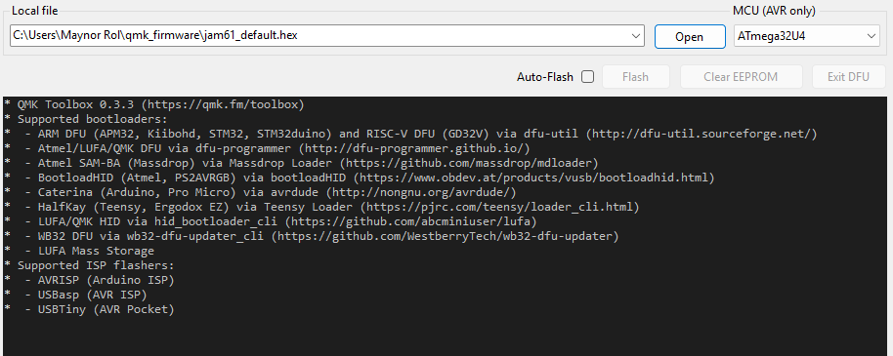

Once this is complete, it will say "flash complete," and you should be able to type on it. If you wish to test it out, there’s a tab that says tools, click it, and you’ll see the prompt “Key Tester,” and you should see your keyboard show displays and inputs. https://qmk.fm/toolbox (QMK TOOLBOX link)

